1. 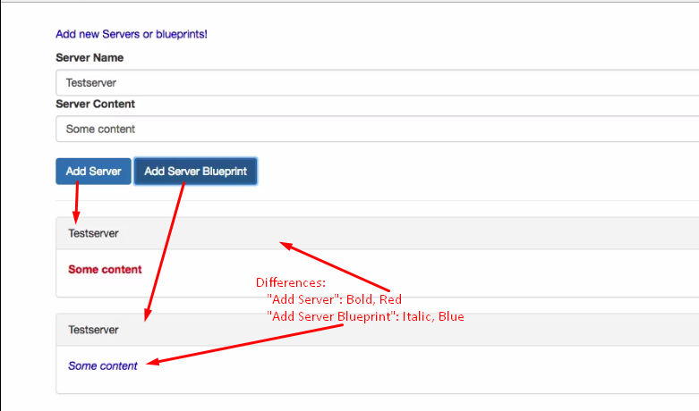
2. This whole logic is running in one component 🡺 app component which is not a good idea. We can split this component into more **manageable components** and can be **reused** in bigger app.
3. Splitting Component into more **manageable components**.
   1. **Cockpit**: Where we add all input fields, buttons.
   2. **Component** for individual server.
4. **Creating Components**:  
   

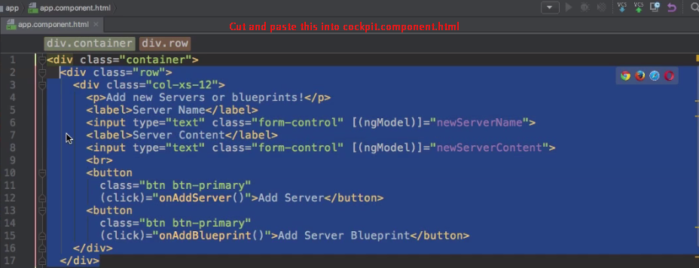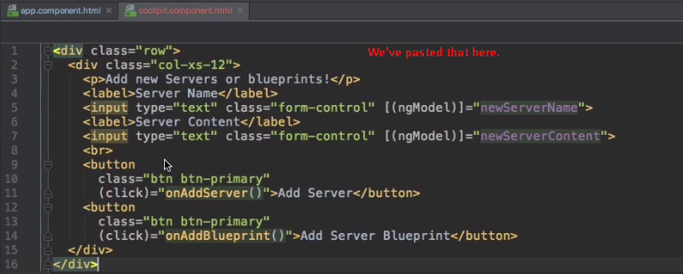

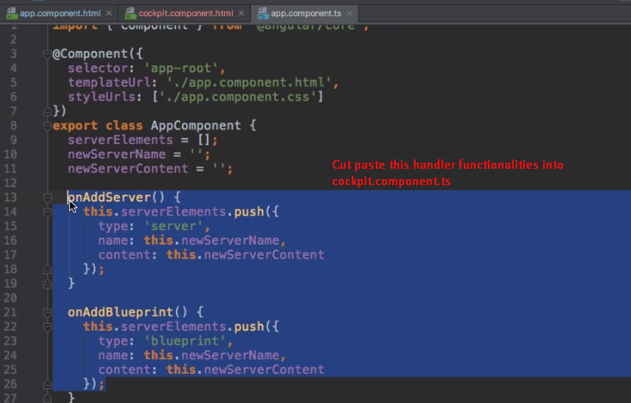

1. I’ve skipped the code as that can be covered in the later lectures.